MEDICARE SEMINAR

# Turning 65 or retiring soon?

Want to maximize your Medicare?

# You're Invited!

Local, trusted Blue KC Medicare Specialists are hosting a Medicare 101 Educational Seminar.

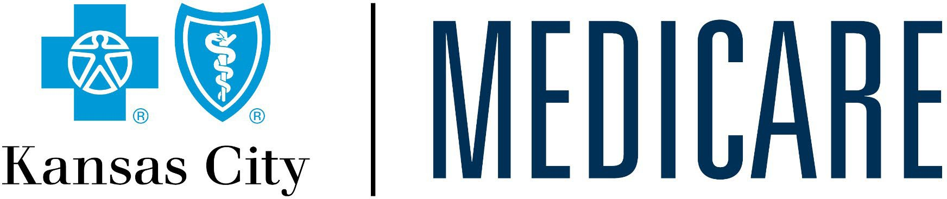

**Date:**

**Time:**

**Location:**

**Contact:**

Blue Cross and Blue Shield of Kansas City is an independent licensee of the Blue Cross and Blue Shield Association. The Medicare Supplement products are offered and underwritten by Missouri Valley Life and Health Insurance Company, a wholly-owned subsidiary of Blue Cross and Blue Shield of Kansas City and an independent licensee of the Blue Cross and Blue Shield Association. Not connected with or endorsed by the U.S. government or the federal Medicare program.

Y0126_23-554_C